Professor: Francisco Neville

Class: CS 3380

Title: GameDev Playtest project

**Project: Ludo Prototype Description**

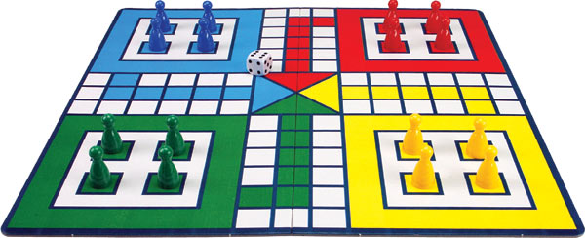

**Introduction**

**Team Info**

**Members:**

* **Franck Dosso : Music design/ director**
* **ThankGod Ofurum: Concept artist/ modeler**
* **Leandro Aguiar: Game designer/ mechanics**

**Idea**

Project: Ludo is a two-dimensional, multiplayer, virtual board game based on the real-life game of Ludo or, as called in America, ‘Sorry’ where players compete against each other by moving their chips all across the board in an effort to be the first to get all the chips across the finish line. The idea behind implementing a variation of this already established game is not only to provide players with a sense of familiarity by making use of the platform, concepts and title they’re already used to, but also to engage them by making use of interactive sounds and music during gameplay, and to redefine their expectation of the game of Ludo therefore making them think harder through the use of various mechanics such as deep pits and black holes.

**Overview**

Ludo is a board game featuring two to four players in which each player is tasked with the objective of getting their four colored pieces through a path to the finish line according to their die rolls. At the start of the game each player is provided with four pieces of their preferred colors which are placed in the player home ground. As the game proceeds each player takes are allowed one die roll each turn and the only means by which a player gets one of his/ her pieces from his/ her home ground onto the starting line is by rolling a six. Once at the starting line the player’s piece moves forward according to the result of the die and, if a player plays a six, he has a choice between moving one more piece out of the home ground or moving pieces on the game board forward. The goal of the game is to be the first to get all your pieces across the finish line.

However, in this virtual implementation of the game, new and challenging rules have been added such as deep pits (player’s piece gets stuck until a six is played or every other piece is ahead) and black holes (player’s piece is returned to home ground). The traditional rule of a player losing his/ her piece once it’s landed on has also been altered, as players pieces return to the home ground once landed on instead. The game consists of two types of fun which are challenge and submission: its appeal to submissive players is based on the considerable amount of repeated dice rolling; it’s also challenging in the sense that players compete with opponent(s) who’re capable of preventing them from achieving their goal by taking their piece away, and the board itself serves as a hindrance for players towards accomplishing his/ her objective.

**Audience**

Project: Ludo is a virtual two-dimensional board game based off the regular board game genre but with a focus on variation and complexity. The game targets players with a taste for strategic games, such as monopoly or chess, with an emphasis on racing, such as hedgehogs in a hurry. The intended rating for this game is *E: for Everyone*, and the desired audience is everyone 4 and up as the game is relatively free of violence, except for player’s pieces being landed on and forced back to the home ground. The game’s mechanics is also easy enough to grasp as player’s only movement is rolling the die, so it’s appropriate to people of various age categories.

**Sound**

To provide more aesthetics to the game sounds are generated in the intro menu whenever the user interacts with the interface. During the gameplay, a theme song has been added to prevent the game from feeling dull. In order to make gameplay more interactive, different sounds are generated whenever an action occurs such as moving pieces, falling into black holes or deep pits, and a computer sound (virtual assistant) has been introduced to help the user go through various stages of the game.

**Key terms**

* **Deep pits:** Gray squares that restricts movement of pieces until intended player rolls a six.
* **Black holes:** Black squares that return player’s piece back to its home ground.
* **Die:** The die will determine player’s moves and actions throughout the game.
* **Pieces:** Each player possess the same number of pieces and they are the main actors of the game.
* **Finish line:** The line to cross to win the game (objective of each player).
* **Home ground:** The initial location of player’s pieces at the start of the game.

**Gameplay**

Player is provided with the opportunity first position deep pits and black holes at any appropriate location on the board. Next players are sequentially asked to roll the die - if the player fails to roll a six, the next player takes the turn to roll the die. As soon as a player rolls a six, he/ she is then able to move one of his pieces out of his/ her home ground to the surrounding game field, and player is able to move his/ her pieces based on number rolled on die. If a player gets his/ her piece into a deep pit, that piece gets stuck until he/ she plays a six; in the case that a player gets his/ her piece in a black hole, that piece will automatically return to the player’s home ground. In order for a player to win, he has to get all his pieces across the finish line.

The mechanics adopted were basically clicking on the desired piece to move it and pressing enter to roll the die. During the game, instructions are given by a virtual assistant.

**Configuration**

In the intro menu, the player is provided with the possibility of choosing the number of players - future improvements include letting the player chose the number of pieces each player should possess and how many of them need to cross the finish line to win the game. The game is capable of providing players with the configurations listed above. However, the intro menu is not fully functional thereby restricting the modification of these parameters to a text file or there is still the option to run the game without the intro menu, but in this case the player will be prompted to type the parameters thereby making it less interactive and engaging. Future improvement also includes providing a save and load operation for game players thereby giving them the opportunity to resume gameplay from whence they left off.

**Variations**

Variations added to the project: Ludo includes the introduction of deep pits and black holes. An extra rule change was the omission of the extra turn given to players having rolled a 6. These modifications help to make the game a little less random and also a lot more challenging. However, upon play-testing the game several times, we came to the conclusion that it was quite hard and time-consuming, and this could turn out to be a huge disappointment - especially for the kids. To compensate for the extra challenges added, we decided to change another rule of the game: when a player gets his/her pawns to the final path of the game board, he/she is now allowed to move it across the finish line based on the number rolled - irrespective of whether it’s the exact number needed to cross the finish line.

**Credits**

<http://www.chiquiplanet.com/board_games/ludo.html>

SoundBible.com and youtube.com

<http://audio.online-convert.com/convert-to-wav>

<http://www.fromtexttospeech.com/>

<https://www.pygame.org/docs/ref/mixer.html>

<https://www.pygame.org/docs/ref/music.html>

**Similar games**

Pachisi

An old board game from India which is very similar to Ludo. The game consist of four players working as a pair known as “Twenty Five” and are tasked with the objective of being the first to move all their pieces around the board and into the center of the board.

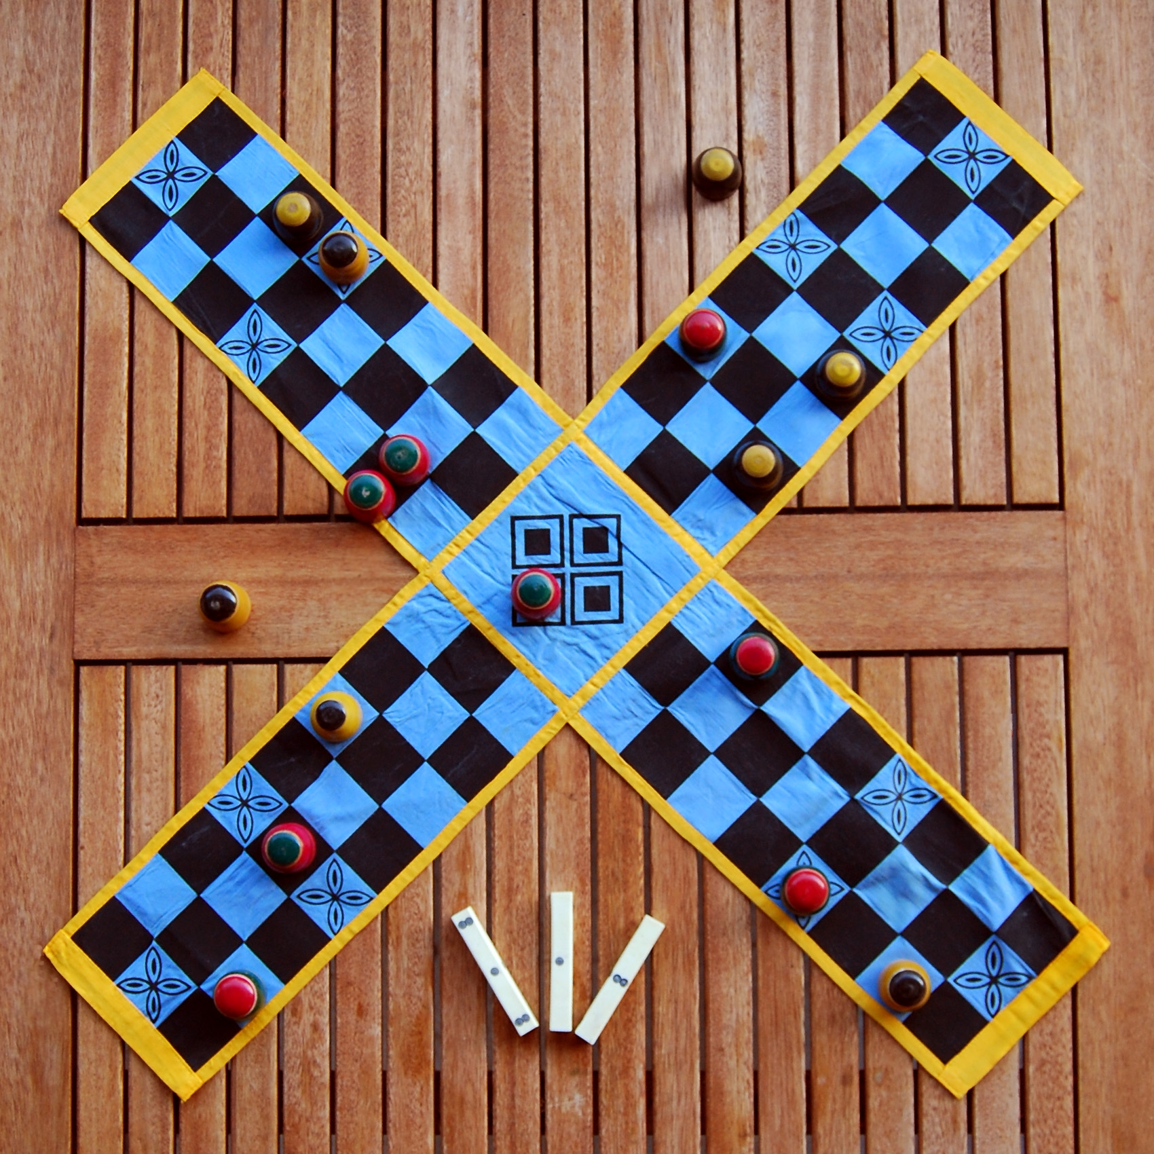

Uckers

A board game is adapted off Ludo in the early 1900 by British sailors and widely played by the armed forces. However, it includes many variants - some of which are: playing with more than one dice, and up to six players.

